**Decision Tree Algorithm**

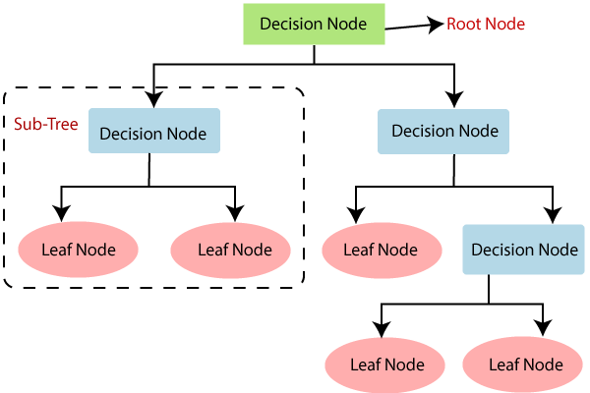

* **Step-1:** Firstly the tree begins with a root node, say S, which contains the complete dataset.
* **Step-2:** will be finding the best attribute in the dataset using **Attribute Selection Measure (ASM).**
* **Step-3:** then the root node s will be divided into subsets that contains possible values for the best attributes.
* **Step-4:**  decision tree node will be Generated, which contains the best attribute.
* **Step-5:** Recursively new decision trees are made using the subsets of the dataset created. Continue this process until a stage is reached where you cannot further classify the nodes and called the final node as a leaf node.